Nextjs is a framework based on React

Through this you can make a React app with high convenience

It gives us





There are even many tools of SEO here.

It makes routing very easy by File based routing (who knows). We will see in future.

So Nextjs is a way of conveniently creating React and SEO friendly website

You get many options to render your website

You can generate a static erbsite that is ont related to the backend then you can export with the help of nextjs . Next js can provide you api routes

It can so backend also. Which makes it a framework for frontend and backend also.

We know React get rendered in front end so if you se front end code then inside it you won’t get page content it is later populated from js in most of the cases which is a great problem for social media sites and Search engines they cannot read your content so engine like google does not rank you. If you are working in plain react.

And Social media site does not generate a preview of your site if you make it by React

As it makes a static meta for any page as all the content goes inside root id element.

Next js solve this problem and make the react convenient

There are some tools you need if you want to start with next.js

And there is setup you should do for Next.js

Next js is present inside node.js

Yes we need React and js for nextjs so Teacher will refresh it for us and tells us some basics and as the concept come teacher will tell them about it.(who knows)

How to make a next js app

To make a next.js you need to make indicidual file also (maybe manually)

But we will use create next app utility

You can

**npx create-next-app@latest my-app –yes**

**or**

**yarn create next-app**

So nextjs gives utility to use react app or component in a good way.

If you go to Home page of Next.js

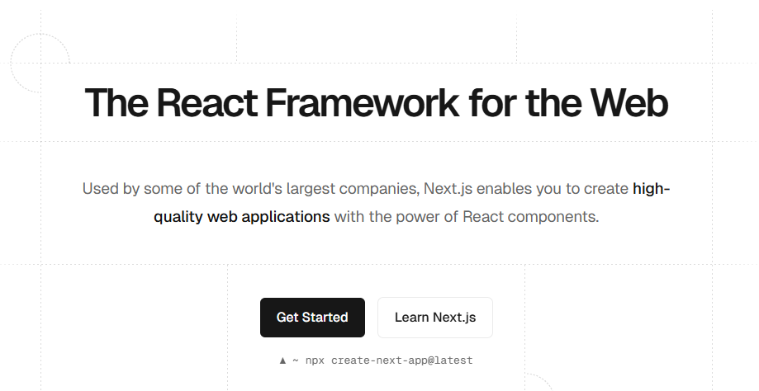

It means this is a react framework and you will use react but on top of react you will se 10 more things



Some other functionality are above.

In next js you can make SEO friendly images within your application you don’t need to optimise it externally

How to upload public files on a server (who knows)

Teacher says yarn is faster better than np mot npx(who knows)

You can install yarn by the command

npm install --global yarn

There are two version of yarn

One is classic usually at 1.22.v

But another is berry which is usually more than 3

Berry accepts latest word in the command

From nowanwards I will use yarn for project making

When we make the project by yarn then yarn.lock file is made

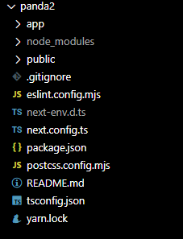

In yarn.lock we see all the information about dependencies we see in out project along with their version

Lock.json freezes dependancy graph means all the dependencies and their sub dependancy will be installed wiuth their the correct versionAnd make sure if the project is installed in another system then it should have the same version dependencies

yarn.lock show all dependencies and their sub dependencies along with version but package.json just only show dependencies that’;s why they are very large in size.

It is related to nodejs bot ot nextjs project(who knows)

In README.md whatever you wrote here will be visible in github application maybe in your repository home page(who knows)

To change this there is a called readme.so

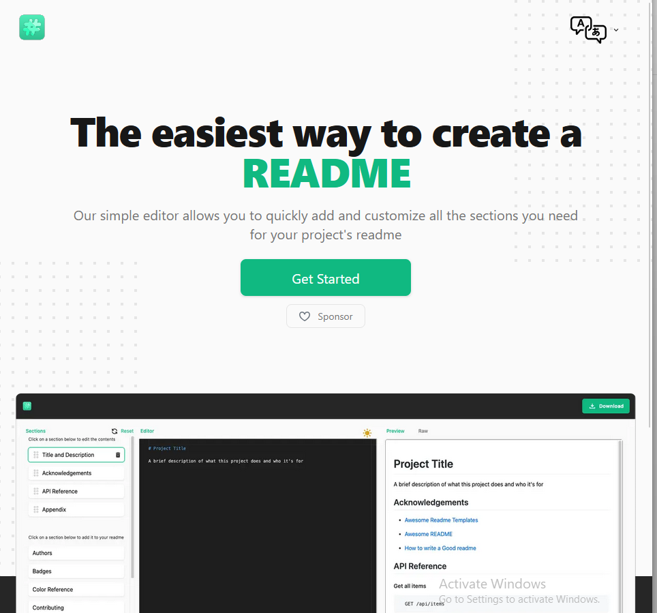

To run a next app made by yarn

Type the command **yarn run dev**

Now you might have noticed that if you try to access a link that is not active or exist then you will see a 404 page unlike react where you have to make it your self as show below



If we create a harry.txt file inside public and then try to acces it url tehn you willnto get 404 error but you will see a txt file

Even if you put a video or any media file then you can see them in your browser

So public folder have all the files that we want other user to access it by using the url

It does not apply to pages folder node modules , .next folder.

I think it will be only in development

And the next folder is very important that is pages folder

In pages folder file routing happens

But in newer version it is change to app folder

Where routing happens and according to AI it is called App routing now

Now whatever we see in home page is rendered in index.tsx (or maybe jsx) but in newer it happens in page.jsx

If we want to add a route that is /about then according to Teaccher we wil make an about.jsx(or tsx) page but I think by a new way we make a folder about and then make a page.jsx there

Next provide you a built in component called Image

We imort it from next/image as shown below



We will look about it later it just provide some optimizations your site will be fadster ans will be SEO friendly

Next js makes your life easy in making an SEO friendly website

You might want o optimize your image if it larger in size and mayu beinn a very good format so that if someone accessing your site does not loose too much data

Ideally you fix image through external tool but in next js we can d this by Image component (who knows)

**You can move the side bar from left to right by going to view and then to appearance and then to move primary bar to left(if in right) or right(if in left)**

We will use simply react and on top of it we use Nextjs component like Image or Head

Now style folder is not present anymore because next don’t mind where css is

In global.css we add the syles we want in all the files but it does not work magically

The _app.js is replaced by the layout.tsx that covers the whole app

And every folder has layout.tsx representing the page layout

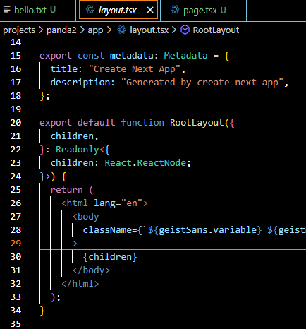

The Nextjs Routing system injects the page component we are in ti the childered as shown above

Every page rendered here will be rebdered from here(who knows)

Every page goes through layout.tsx of app

We import global.css here due to which this css applied in all the pages.

**We can import style classes(or maybe id) In our component and use it to apply the properties associated with that class as shown below**

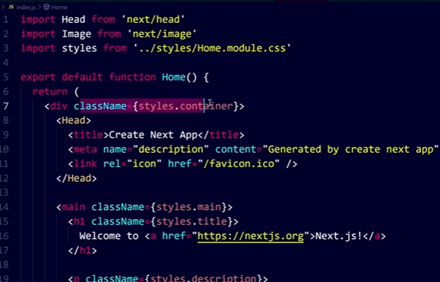

By this way you can make your files of css and you can use them in your individual components.

**You can install Tailwind css into Nextjs**

Follow the link below



If a port is busy then another port is chosen for development server in next js

We will see why file based routing is a convenient function in Next.js

Convenience function = a ready-made helper that makes a task easier and faster to use.(who knows)

Routing that is used to happen in Reactjs Now does not happen in next.js you can simply make files like php or simple HTML website(who knows). You can enable page routes(who knows)

We will see how to make simple routes, nested routes and how to make dynamic routes and how to structure your application



**I think that in gitignore whatever name you write will be ignored even in folders or sub folders.**

We alos .next in the gitignore.

Id Nextjs is frontend or backend framework

It is framework for frontend as as backend

Because from here you can even make api routes as well(who knows)

Just like styles our api folder is also have to made by us and it is usually present in the app folder.

And inside it you can make api routes just like shown below



As we can make api routes this is a backend framework.

Is Nextjs better than Reactjs

Bbith are different things

React is raw , React has core end development (who knows)

Next js uses react to solve some problems

Yes it is thankfull to React.

But we cannot compare them as it uses react we can’t compare them

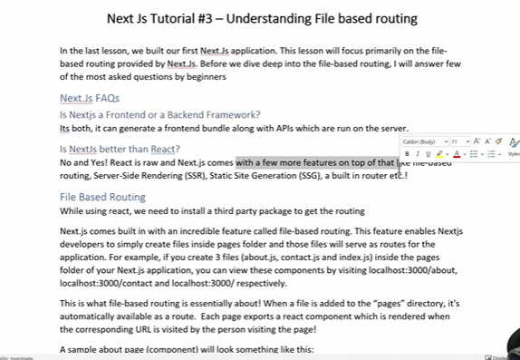

There is a think called Next Head which give us very much convenience

**Teacher also learnt Strapi, it’s a headless CMS**

In modern world the Head element from next.js is useless

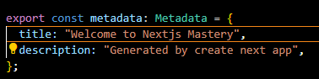

No we use above code in layout.tsx to change title or description.

So whatever component is present in the page.tsx will be displayed in the Home page of our website

Unlike other framework you get your default 404 error page.

You enable or disable an extension for a workspace by going to drop down of enable or disable in the extension information.

Its like PHP or if you have made a simple html sites.

Add a folder and inside it add page.jsx you will get end points

It’s the same in jsx(here I am wrong) this Is file based routing

It is good because it keeps us tension free. You don’t have to vonfidgure too much

There is no need to use router, switch etc

If you were using react you may have had to use all this you won’t have to do it here.

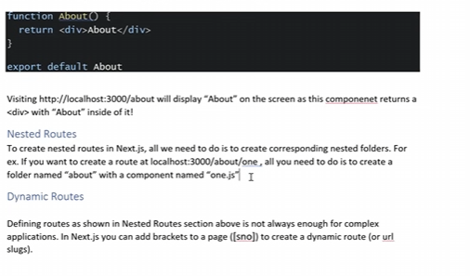

Now by dynamic routes we mean we want to pull dynamically from the database

If there is any slug in the database

What actually happens is that whatever comes after the defined slug in the app or its subfolder is treated as a parameter like mostly last text in the url after last /(who knows). This is happening through dynamic routes.

According to Teacher you can add square brackets to the last of url to add dynamic routes (who knows)

In React 12 the default component was client

But in React 13 the default component is server we can tell a component is client side by writing “use client” on the top of the component file.

And in now new version we use useParams but not useRouter for client side Now the component look like below

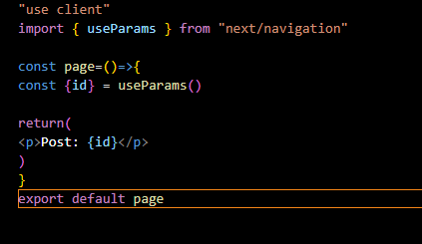

Teacher will tell us enough javascript of React to start with next.js

We will discuss topic that you may get stuck in js we have

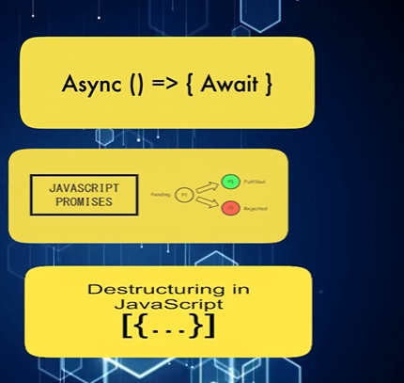



React was made so that user can easily create user interfaces and we can do event binding properly(who knows)

**What is Event Binding?**

**Event binding = connecting (binding) an event (like click, change, submit) with a function (handler) so that when the event happens, your function runs.**

Another reason is that if you want to change content dynamically like element in the website then by js code you can do so

Now suppose we want that when we scroll then some elements content dynamically change then we write a very simple code in which I will say if I scroll then change a particular variable(maybe representing the content in elements ) and that variable will be state(who knows) so this is a concept in React.

Some components are

**spread operator** as shown below

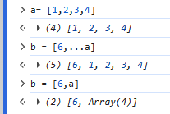

Leaned new thing about spread operator

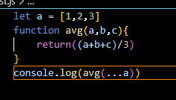

We can use spread operator to pass the elements in the array to pass as an argument (in the order they are in the array) to a function who has ordered argument as shown above.

Next topic I already know that is destructuring

Next topic is promises and callbacks

Promises is something that will happen bit it has not happened yet It si going to happen but it is going to happen and when it will be resolved(firm decision) and if it’s failed then it will be told to you (who knows)

So when promises get resolved then it do something when promises get resolved then a callback get run. Or you can await it which is a concept of async await. What happens here

Is that an asyncronous function can be made and inside it there will be methods that are returning promise and will wait promise is resolved

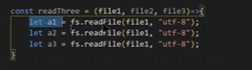

In above code a1.a2 and a3 is a promise. And we will wait for it be resolved so the async function will slow down

So there are concept of map, filters and reduce

To learn more we are going to make blog named as “Hunting Coder”.

We will see how nect js helps us in SEO

We will research about SSR and SSG feature that are there of nextjs



How to include them in our blog and make it more profitable and he will tells us how search console that is Google product and google analytics how we add these things to out blog. So that you can analyse what traffic is comping and where it is coming from what should you do?

What are core web vitals(who knows) Is your page speed too slow. If it Is too slow then what page is slow and then how to improve it. and we will learn it through this project and he will also explin the concept of next.js here through this project.

Like we talk about Next Head(outdated) or next image and there are many other concept in next.js

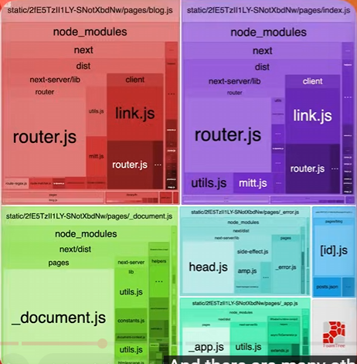(who knows)

We will take this project to the deployment

Hunting coder is what who hunts for skills, quality work , who hunts for bugs and in blogs he shares his experience.

We make a Hunting Coder next app by tunning the create command in powershell (Teacher will explain later)

Teacher says yen is very fast.

Instead of yarn run dev you can also write yarn dev(who knows)

In this website according to teacher the hunting coder solve a problem in an easy way if a difficult methos exist here.

If you do any silly mistakes like closing tag without opening, HTML tolerate this type of error(I don’t know how) but jsx don’t . Sometimes een js tolerate some errors like you are not adding semi colon(who knows) If in htlm you made an opening tag without closing it then browser parses It according to it.

The logic looks simple when we work with html, css and js but when we are In next js where component are exported (who knows) to make it easier Next js use to have a Head component but not anymore Now we delare it like below

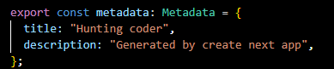

But Next Head component was used to change title of the page(or inject content in head of page (who knows))

This Next head component help us to edit the head tag of a page directly

With this we are in the power of the nextjs nut because if this we get good old HTML CSS nad js feel (alas not anymore)

Can we do it by js obviously we could do it Title can be set dynamically like you do in react.

But next js gives us a convenience function.

Now if you see the source code then it is compressed 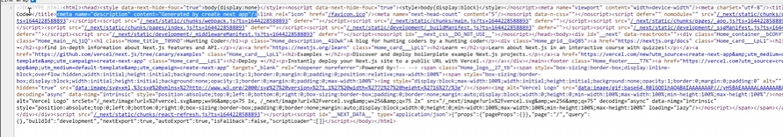

It comes in statight line but above is line wrap applied

Because of SEO reason

So this was Head OK? Now suppose if you want to add external script Let us say we want to add google analytics , consider we want to add search console code(who knows).

Consider giving us any code and someone said that to add to our page then how we will js in any page so we can add external js in our page so we can add google ads and google analytics scripts

Some times it happens with js is that it takes more time as execution becomes very heavy and because of that page becomes slow.

And you would not want that some third party trying to use some analytics your page becmoems slow.

First are your users if your user is able to take service properly of your website or able to consume the content it is a great thing.

So what happens there is a Script component in next js that we import form Next/script.

How it is different from normal script

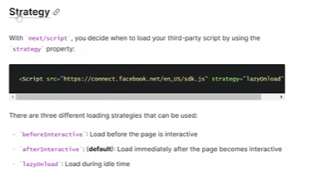

We see above its attributes and its nameis strategy ( think so). One is lazyload that is when there will be free time. When all our work is fne after that your script will be loaded.

You will want to use this inmost cases.

Another attribute is beforeInteractive and another is afterInteractive(default

So I add strategy and give it value lazyOnload by this when the page is fully loaded then this script will run.

if you add any third party script then it make your page slow Because for this script it don’t care about you whether your page is fast or slow They just want us to use their service.

If you say this script is slow then they will say do lazyload How to do it they won’t tell you. With plane simple js we can do this but in next js you can do this work easily.

Teacher is doin lazyonLoad.

So Teacher did use lazy onload strategy.

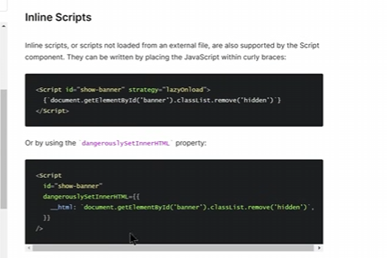

Never add script tag in Head element.

There is a property that is dangerouslyinnerhtml

Now if you

You will not be able to understand documentation but you will if you are at intermediate or advanced level.

If you work in any html, css , js and any framework.

Then there are high chances that when you use images then you face this problems

Such as image size is 20 MB and in your size image is getting loaded whe any user opens your site.

Which makes your site very slower and destroy your Google Search rankings. And in next js this thing is improved a lot. And it is because Next js provide an image component in it.

This image component automatically optimise This image is by default lazyload.

Means the image that is not in the viewport which is not present on your computer screen.

And it is below and you will scroll it later from that type of image page sped won’t be penalised.

This means that the full page lets consider it will be loaded in 2 second maybe it will be loaded in 300 miliisecond. Because only that images are loaded that are in viewport the ones that you can see in screen. So these type of tools make the nextjs strong

The Image component actually provides you optimised images OK so if you are using any image anytime then behind the scene Next js will optimise it(basically making a page ) by using its power.

Which means some logic code will run. That will optimise your image. By default the images are lazy loaded. Lazy loading means that if your images are not in the viewport. Then they won’t be loaded. when will come into the viewport they will be loaded. Because your images are lazy loaded.

So what soes your browser do when you do lazy loading of images Them images are loaded when you add them to the viewport

Along with this we get the functionality of making the image responsive which is provided by nextjs

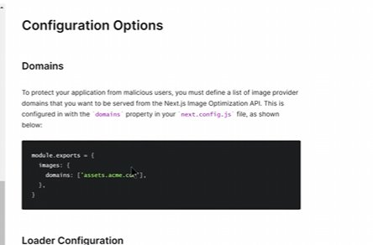

So there are many nextjs configuration options(maybe attribute).(mentioned in documentation) (who knows)

There is option(attribute) that is loader, sizes.

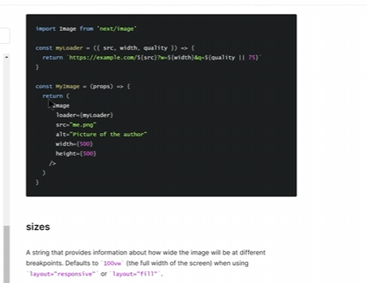

It is same as img in html but it is an optimised version

**Note:-**

Emmet might not work because of this reason

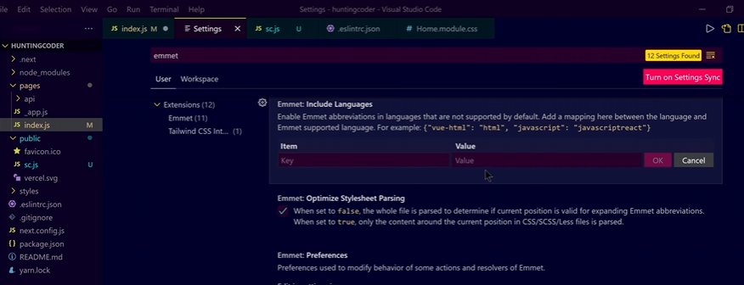

If still does not work then you can go to language mode by opening any jsx file and according to its extension a bottom right option will be there as shown below

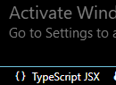

and on clicking it a TextField will be shown om top ,choose javascriptreact after typing it.

You can use CSS as a module just use the extension **module.css** then you will be able to import class names that have styles from it as shown below



And use It like below



Otherwise you can import a css normally and set the classname with string like you do.

Teacher says first make sure that the website runs and then you can style later . Because if your website tuns and works if there are visitors coming on your blog and they get any value.

Only then something will happen or else nothing will happen.

When you add elements in html then you need to tell that what is main heading

We will learn how to make these pages in next js

We know in react for routing we use react-router-dom we need to install it separately and Teacher says it is very painful when you use react router dom and configure it to render different component on different url. This thing is very easy in nextjs that you have pages(now app folder) folder

And inside that folder you have your own react component you can make that and on the basis of your file name your end points will be made(in older version) automatically you don’t need to do anything

In react we know if we are going to another page then it is very painfull to do it.

This thing has been solved in next js. Firstly we have file based routing if you have to migrate from one page to another page. Next js provides you link component which is imported from “next/link” and can be used very easily

You can still use your old a tag to go to another website We will see how this link component is different from anchor element and when we should use what

Now when we route through anchor tag then loading happens the link component saves us from reloading which means all the work done by js. JS populate the content.

The reloading happened through js means data of our page that got populated over here that’ the beauty of next.js link component

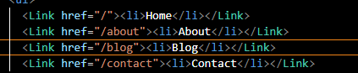

Now Link will look like above

Now we can reroute another page without loading

Previously for a link to be look like it we used to wrap it around a inside link but now Link by default come with that look

Sometimes we need to make a very complex application which does not means complex to understand it measn use case is very complex so we see the documentation of the component t we are going to use

So always refer from docs

One attribute that get added to the Link is scroll If we set to false then if we go to new link then we disable scrolling at the top of the page. You do this when tow page of yours are gettgin linked against each other (who knows maybe chang e I one page reflected in another page in the same location)

You can do that if your overall application is connected for example if you are creating a social media network like facebook then what will you do. You would not want to scroll on the top is someone clicked on the chat or you are loading another component ans as the component loaded you would not want to be scrolled

Sometimes you might want that we will use this css for this component or this css fpr this component how will we do it. What will be the strategy while working and why would we do this work at the first place Now we will see CSS which is a very important thing

How to nectjs manages the css increase it popularity

In next js you can use component level CSS

Now previously there was [Home.modules.css](http://Home.modules.css) basically it was for home that is index.js(Home page at that time) so we imported in the component we want to use it in so I will just ignore it.

Now next js takes importing beyond js basically the concept of importing is modified by nectjs

The cs module should have .module in its name.

Now what happens is that if we import a css file like a module then console log the module then we will see that there are key value pairs like we see in object as shown below

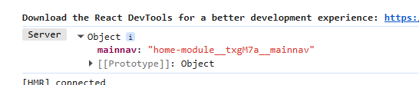

What is happening here is that when we import css module file then an object is created in nexrjs page (amybe currently opened in the btowser(who knows)) whose keys are the clesses that we wrote in css and the value is a unique value and such a unique value that will not collidide lets imageing you bring css from somewhere. And you define a property with the same class now which class will win So to saveguard us form it module.css or css modules are made.

Now when we apply it these modules like below



Then BTS next js works a magic that is it go to the css file from where styles object is made and then apply the property associated with the class name same as a key in styles object to that element className.

Okay bit now next sj has responsibility that collllision shouls not happen

Now Teacher is giving us ecample if we have two moduels having class of same name

Now you can choose variety of styles Now when the page will be rendered there will be a unique string for that classname. And it is the reponsisnilty of next js that the string will be unique.

It never will collide. If this was not done then when we have faced difficulty that is when we have used multiple classes colliding with each other but next js made them unique string and prevent collision.

Teacher will tell us how to structure css where you should you use which class(who knows). What strategy you should have with css in your next js website

Tosay we will learn like we uses ot so stylesheet how we will do it here.

So we writ a simple css file now I want that to be attached to out page so we import it likr

Import “address of the css” file

Ans remember component controls when the css will be loaded and it retains even f you move to another page.

Previously you could not apply css stylesheet to a single page and it gave errors to now but now you can but it is not rexommened to use stylesheet for one single instead only for global.

But you can add styles from node modules

You will say why can we do from node modules and why can’t we so it from here.

So importing a css file from node moules is permitted If you have installled a pckage that has css file in it Like consider you have installed bootstrap and you want to import css in just one component.

It is not recommened to iuse stylesheet like this

Now you will ay what is this layout.tsx

From here is you load any page of nextjs app then it is loaded from here.(who knows)

**Always apply stylesheets to all the pages I layout.tsx and module to single component only.**

No matter how much you use the technologies like next.js but ont thing you will miss is that HTML, CSS and JS. The way things are done in them. Plain and simple like keeping things vanilla. The way thigns are done (who knows) we always miss that method when we come to complicated technologies. If you want to target styles with classes in next.js(who knows) Then you can use styles jsx syntax(maybe recognised by next.js). It is a very nice thing. You will simply do the same work like you do with css. But in a very well environment by using next,js powers Come and lets see how styles jsx is used . Don’t fear from styles.jsx Because it is such a thing which is very simple you write css and target classes and that will be applied to that particular component This is not global But can we make it global such that if we want wherever this component where styled.jsx is used is getting imported over there I can use styles jsx.

Simply you just need to make it global by adding global attribute on it



Style.jsx is basically a way of adding a style to a component.

Basically what we will do is that we will use a style element or component(with jsx attribute) or whatever it is and then in its content use backticks inside the curly brackets for js and hten write css like you do invanilla.

But alas It is supported in pages router not app router so I will just learn it theoratically

To make it global apply global attribute as shown below

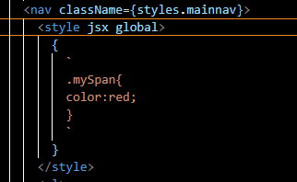

Teacher will deploy the project like a real world project(who knows)

We will so some cleanup by clearn up we mean we will remove some unused files.

Teacher says that redundant files are harmfull for your codebase because in future when your codebase will grow then you will not know what is useful for you and what is not (who knows)There is an API that is unsplash APIand you will any get images if you sing I there as a developer

So we registered there and make id there

**New discovery:-**

When we add border radius to an image then its border get rounded.

In Teachers project we can see navbar only when we are in home but not in another peoject

So instead of using navbar code in every component no because Thankfully we can edit the layout.tsx what is it , its function why edit it. and how can we display navbar in many pages.

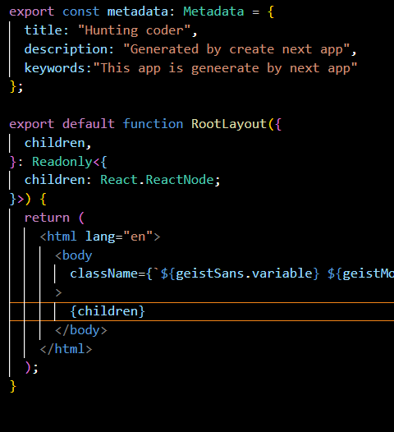

The layout.tsx is that file that is fired when any page is loaded it wraps all the routers and the children represents the different component in the layouts. In previous version **the component In _app.js get rerendered every route but not now only childered are rerendered , mounted and unmounted in layout.tsx(I think so)**.

Teacher says that whenever you make styles then try to keep it very much optimised(who knows)



Now the output look like above.

**We can tell the word length of the lorem ipsum in VS Code by typing lorem<No of character>**

In the upcoming lesson We will learn about how to add different post in blog.(who knows)

If we configure some endpoints and tell you we are going to use a backend then this application will become complicated so what we will do is that whatever blogs are going to be on this Hunting coder we will store them as json files and in gfuture we will see how to do it more efficiently but for new we will make a json files. Which will have the data of all the blogposts. And we will read thse json files from file system we will display it We know it is not the most efficient way its efficient way is database but Teacher want to make this code beginner friendly so we will make json files and read them from the file system and populate our blog

Now to add data we have to store the data somewhere why not use a database ot headless cms or API routes All these things they are easy if you know them but are somewhat difficult for beginners.

**Spoilers :-**

Next js can be used for backed as well.

Now we make local json so for that we make a folder BlogData

In blogData I am going to add json file whose name is how-to-learn-javascript and we will add some content there.

Like we add title , content key you can put a lot of data here like the date and what else things like slug and author you can put foreign key for comments(who knows but complicated)

Suppose I want to add html as content or just content (who knows)

**Because of newline you may see error in a string in json so shortcut technique is paste the string in the address bar the address bar removes the newline in the string**

Now we added author key

Now as we made for it we will make more json files

Now after making these files we will show their data in out blog page.

So we will read files system after reading it then we need to show our date in out blog page

So we can use map and make an array but where that array will come form I also a big question

I will do practical no discussion for now

**Question?**

How can we get the json data without reading the data from client side by reading file system, and we should do just by using next js not by another technology.

Do you remember that at the start of the course Teacher asked us that Nextjs is a front end or backend framework and Teacher said it is a framework for both It definitely for backend and frontend as well. We will see how to create api routes in nextjs After that we will see how the api folders in pages or maybe app can be populated and Nextjs can be written That backend will not be shipped in your client bundle.(who knows). It won’t be shown to your client. We will see in the API folder in pages how file based routing works. We will see the json response in our browser and then we will see how you can use these API endpoints. We will see how to modify and access request and response objects. We will see all this. Lets start with our API introduction

So now we will see how we will serve the data from our Json files. In the previous lesson I asked you how the json file could be served. So we are going to do it today.

In our blog page we want that all the json got rendered and get visible here. By visible i mean that my json has information and I want it to be visible. Now our json is in in blogdata folder. Now we want that particular json to be shown when its corresponding slug is hit.

Teacher introduces us to Nextjs API. There is an api folder in app folder( and it is same in older version where there was pages folder). There are some things that we have not touched yet. We talked about Nextjs is a frontend framework or if it is a backend framework. He said it is a framework of both How is that possible. see the code we write in app ( or pages ) in about,blog folder(files in old ways) all these are front end codes. But Today we are going to make backend code. We will write the code in api folder So Teacher in his old version of next js create a hello named file for an end point

And write a code like below



But now It is outdated now our folder structure is like below

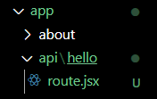

So all the code will go in route file and instead of express like api we use web request/response API like below

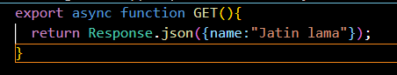

Suppose we don’t know anything in next js and we try to hit the hello end points Now It looks like below

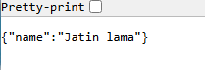

So by this way Nextjs has become a backend framework That means we can make api routes we can make simple APIs and the code will be written in route.jsx(in file name in older version). It will not be visible to our client This is called backend and all these routes are called Route handler. In backedn we can code here through Next.js. So Nextjs is a backend of both.

So we will write backend code here

So we will install **json formatter** in chrome

Now by this in chrome you can see the api data in Raw and parsed form (beautified form) and thing become very convenient.

If we console log here then the output will be visible in the server side. as it does run in the server side.

If you leave next.js. If you make API in nodejs where do you see the console there? Its in the backend in the private server not in the browser. So the same thing is seen. Previously request used to show so much but in new API I think it uses Request class static method.so it just show Request class while printing Request. We could have basically print whatever is in the request to a file(in older version). But we will do later. Similarly we can do for response object(in older version). And we can copy and paste it into a json file. Fow now we will move on skip thing . What you can do in app file routing. similarly you can do so in api like making siffernt route for different api.

You can add get, post and many more type of request. You don’t have to make your API in MERN. You canbeing all youe API here and add them there. Now you might know how to make json endpoints

In React Course we saw MERN stack. Here you don’t have to make separate API in node.js. you can make them yourself here

In the previous lesson we took a good introduction of API. We saw in the API folder. We can populate some react component which will be part of your API. They will be part of your backend server. This means they won’t be shifted to the client bundle. Now what we will see how we will populate the blogs page with blogs. How can a single blog be accessed with a single slug and we will also see how these thing Nextjs frontend and backend shake hands with each other.

IN last lesson we saw how different api end points work in nextjs.

Now we will see that how the files we made in the blogData can be exposed as an endpoint.

So that we can use them in our blog and blogpages .which means when we click on any blog in the blog list shown in blogs page then we can click on any blog then its detail will be shown in blogpost

It is very important you should know node js slightly

We could have made a js file and then exported the object but I want to work in json so that we can easily send json to the client.

We can see code t read file from nodejs documentation

We will not use the promise way

Our modern code look like below for now

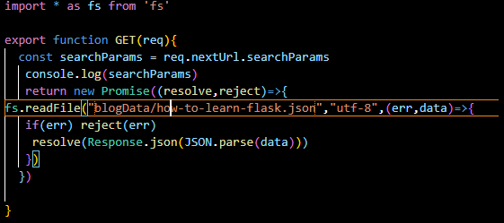

With experience I have learnt that it is mandatory to retun in nextjs and next js demans that we return response object to a promise that resolve to Response. unlike nexrjs where nly res object is responsible for returning reponse and Node wiaits until you send the response for a certain point of time. Next js shows error when you dores not retruun Response and below are th e modern practices code

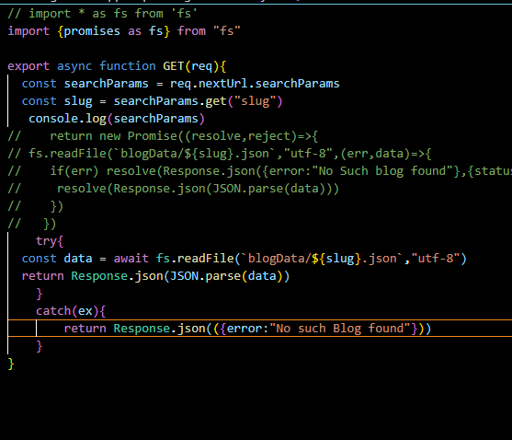

readFile is for reading file content

and readdir is for reading directory’s file contents.

Now for blogs api by which we expose all the blogs we have in the server

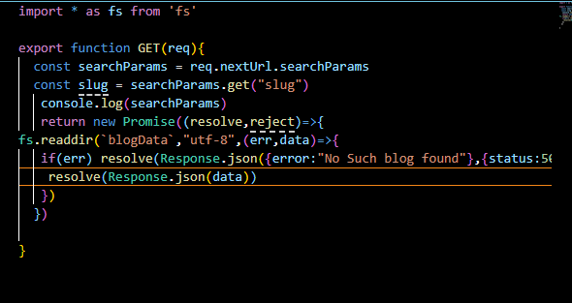

So now endpoints are ready

So far we have just make endpoints in nextjs but unless we don’t use it in the front end then pour application will not be able to use it So now we will create a connection between front end and backend we will see how the front end code where we write html , CSS how it will talk to api of backend and how we will make strategies due to which we call api routes

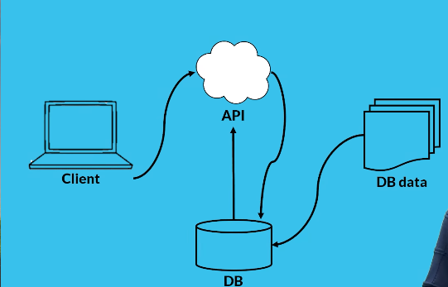

Now I will do practical just paste the code

Now our blogs code lok like below

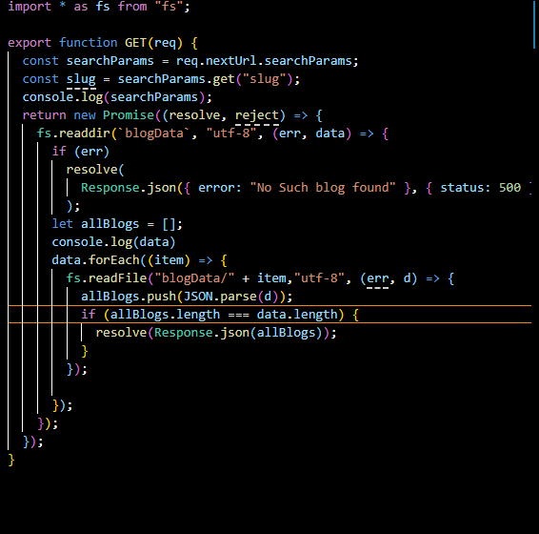

It shows all the blogs to the front end.

So out blogs page is made now we will make page of blogpost and we will learn how to give this blog a final shape

**Note:-**

Dark mode is an extension that you can use in chrome.

In newer next js no isReady Is needed as the data of the parameters is readiliy available In the component.

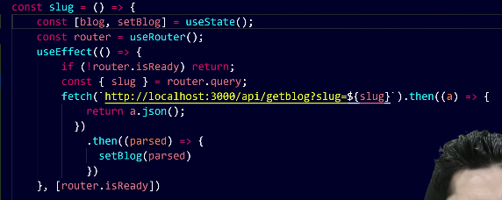

Above is old way of routing in Nextjs. Teacher in future will tell us concept of prerendering and how it is done and why it is done. And we will see how to make the data ready on the server to make it ready beforehand (who knows).

If you look at the current scenario that if we reload out page of blog then we are hydrating it just like react which means I am bringing the content to the front end. And if we see in network tab of inspect then APIs are being used we don’t want that we use API here we want that our data should come already loaded in our page. So if we view our page source and search the html content of our article then we see nothing as it loaded by js by which what happens is that social media bots won’t be able to see my data as they will see it without running js see the source code. They may not prefer me. And they may show preference to someone whose source code have this content. And it will become very easy for our social media bots. And it will also be easier to scrape if we hydrate the page well in source code too. We have already populated the content in out page but we also want that it should also be populated in source code.

Now we will learn about prerendering and how it works in Nextjs.

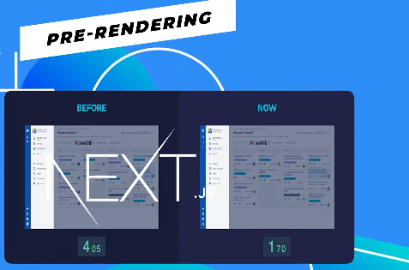

What is prerendering. When you visit a typical web website. Then html, css and js are shipped but in html all the content of the page is not there. By Using react what next js do is that vt default it sends pre rendered page by which you SEO is maintained the social media bots and along with the search engines visiting you can get the content and know that your website what it is about. A react application is rendered with the help of js which means that it for some reason if js does not executed the page content does not get executed this is a big problem and t solve this nextjs uses pre rendering two primary strategies first is server side rendering and second is static site generator.



In server side rendering what happens is that your server send all the data to the client (maybe html also )and your client as it talks to the server with that server will send the data(who knows) to client. In static site generation happens is that your whole next js site only it frontend bundle(or maybe a part of it (who knows)) converts into a static site and after doing this with the help of CDN



Or with the help of any service that can send the pages real fast.

You can use it and with the help of it you can do the delivery of the web pages in a speed and now if you feel all these thing confusing so please be into the course and teacher will tell you these things step by step that how to do server side rendering, how to do static site generation and what are the mislaneous (of different kind) strategies there in next.js what will we have to use and when everything will be told to us in brief. We should use Static site generation when you are using blogs and all content of the blogs don’t change frequently that is why there static site generation can be used but those pages where content frequently changes just like the facebook feed of someone’s social media or feed of your twitter or the data which is getting updated live for example live news there you will have to use server side rendering



You cannot set it statically because the data is being changes live we will see how these thing works

Its time to understand prerendering Suppose there is a random blog as shown below



If I am human then we can read whatever written on it but if I am bot then we will not read this we will read the page source



Whatever is written will be present in source code it may happen it is coming from js maybe an api populates it and maybe possibly it is already a part of html. Yes it is a part of html. If I am a bot then by fetching the html here we are not talking about execution of js just by watching the html content and understanding it can tell what is written on this blog it better or I should run the js if run the js if I run the js what will be the disadvantages first that is if your Api is down for some reason and if someone reload the page or loaded for the first time what will happen. If the api is down then nothing will be seen because your data is coming from Api so if the Api is down then nothing will be seen so this is a bigdown. Another is bots. Bots are not just a bad thing. It can be a good thing bot can be a google bot. it can be a social media bot. How do you think the sites like linked in , Facebook etc don’t so it manually don’t put system in their data. You might have seen in whatsapp when you paste a link then what is in the link you see its reflection and same ycan bee seen in facebook that how image get populated too. So how that thing is done so the bot reads the page source so if we can see the content here so it is a good thing bot won’t do that much hardwork it is possible but in most cases the basic bot can read your content when your content is visible without executing js most of the bots are those who read the content and bring then they don’t wait for js execution because they don’t have to read your website they have to read many website too If we talk about Google bot this will help you if show what in the link its reason is that it will show it by reading from the page source do we have to ensuring a thing from nextjs that our content should be in html. So this is possible in hunting coder. No it is not. If we open our flask blog tehn we don’t see it in out HTML Bow suppose if we want to rank out website and google see that in our source code there is no flask in the source code. Then google will understand there is not flask it won’t run the js if the js will not run then our blog is not about the flask so it is not a good thing. So what we do is use prerendering strategy so in out page source we can see the content. Now it can be done in two ways If we see out source code we can see that by using js we will fetch the content with the API later. As shown below

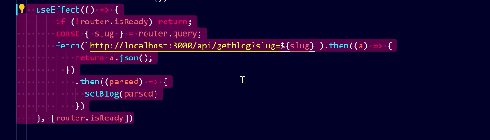

If we want to do this thing beforehand then we need to hardcode these pages in the blogpost we have three blogs but we have made only one component in the blog and that component is taking care of all the things , it takes the slug and whatever blog written by us in blogData it is populating the blog data in our component. So js runs if we type code this way. So What nextjs provides us two types of pre rendering strategies first is static site generation and server site generation. So understand them both and it is very needed to learn about them otherwise there is no benefit of moving on. So what happens in sever side rendering that you html fiels will get hydrated in server. By hydrated we mean the HTML who don’t have mention of the content will be converted into HTML that will have mention of content. Now if you generate an html file. In the server and then send to the client which already have a content so you have to do this manually no Next js already have the feature and the energy of working its name is server side rendering means the page will be generated from your server which will be SEO friendly and its source code has a mention of content. Ans after that it will be sent to the client. So the client don’t have to hard work of running javascript. You can do it and the js will in client but to populate the content javascript won’t run and to populate the content nextjs does this job. So we need to understand this. In our huntingcoder blog there is no such thing but SSR can do this for us

If we changes the content in server side rendering suppose we change the content in backend will these changes be reflected. Because our content is generated on server. So what is server side rendering suppose we are a client and server says that you don’t have to run the js to populate the content I am there for a reason I will give you html which will have the content already. It is server side generation Now the client will ask the server how you will get the content then the server will tell here at the end I will fetch data from the data base we have the responsibility picking up the data from the API and hydrate the page. Client gets happy it is server site generation So in server site generation pages are being generated o the fly as the client request the server hydrates the data by getting the data from respective files and sends it back to the client so all the work is in real time Now we talk about static site generation

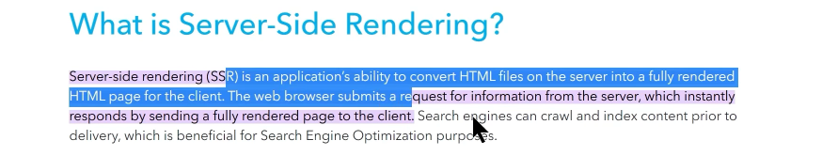

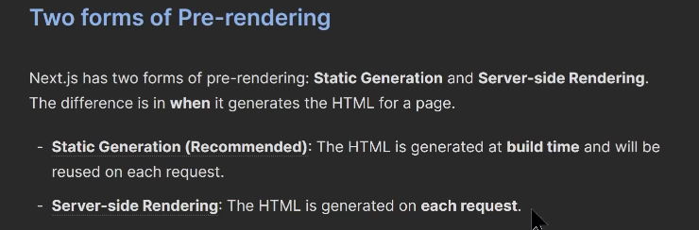

You can see in nextjs doc two types of pre rendering is given that is as shown above. We talked about server site generation now we have to understand static generation. What happens here is that server says that I will generate whole site for you and then I will go away to you can do it in your development environment (maybe created by you(who knows)) basically the hunting coder blog will convert the site into static site sever will not be there. Obviously if you wanna run the api you have to run the server too but here we are talking about front end. There will be a bundle of front end and now with the help of that we can generate a static site. Static site means assume that an image of yours is a static assets it is not getting updated it is not like the same image will change in future it will be cached in our browser or cached through CDN (who knows). and the delivery of a static site is fast. So if I generated a static file. So if I generated a static file means for every page we generated html file then a static site will be generated for my complete site. I will deploy a complete static site for us. It bring the change in the sever will the change be reflected in the static site which is already deployed Because when we generated the static site then all the content will freeze. The content which is available its static site will be generated and when we deploy the static site it(maybe file) won’t check the databases of the huntingcoder what I am putting here or not the data there got freeze. Until i redeploy the static file won’t change this is the major drawback of the static site generation is that if you generate a static site after that you cannot change it until you redeploy it. Incremental static generation (who knows) is also there till then understand there are two types of major prerendering strategies what are they doing, server site rendering on every site generates an html file which has its content on every request. In static site generation already of the complete site static site is being generated already and now we will deploy. Assume we generated a static site for you and send the zip to out email and we do some changes in the huntingcoder to improve it. even if you deploy the package it won’t update automatically because we make changes in hunting coder it won’t relate to the static site.

In next lesson we will see how we will use these strategies. First we will do server side rendering and then see static site generation and see how it is done.

Now we will see how we can use **getServerSideProps** can generate html through server. That measn client will send request to server and once the server receives this request then hydrate the page through all the apis. And apply all the logic needed to generate the html and finally send the generated html page to the client which has all the content written In this way the client won’t have to fetch data through APIs. And the first contextual paint will be very little

**First Contentful Paint (FCP) means the moment when the browser first shows any text, image, or visual content on the screen during page loading.**

If **First Contentful Paint (FCP)** is **low**, it means:

**The page shows visible content very quickly after it starts loading.**

and the page will load faster. Lets see how we can use getServerSideProps function we can do server side rendering

we are going to make our blogs page such it will not be generated by server side and will do the same thing we are doing by client side as shown below



Now we want that it must be visible in our HTML content or become a part of our HTML content so what we will do we will write a function that is getServerSideProps.

**so there was no server side component in older Nextjs**

Short answer:

Correct—older Next.js did not have **Server Components**; it only had client-side React components with special server data functions.

**In older Next.js (Pages Router)**

There were only:

* Regular React components (ran in the browser)
* Special server functions:
  + getServerSideProps
  + getStaticProps
  + getInitialProps

Example:

export async function getServerSideProps() {

return { props: { name: "Jatin" } };

}

export default function Page({ name }) {

return <h1>{name}</h1>;

}

Here:

* The **data fetching** runs on the server
* The **component itself** runs in the browser

So:

Server → fetch data

Browser → render component

There was **no server-rendered React component**.

**In modern Next.js (App Router)**

Now:

* Components run on the **server by default**
* These are called **Server Components**

Example:

export default async function Page() {

const res = await fetch("https://api.example.com");

const data = await res.json();

return <h1>{data.name}</h1>;

}

Here:

* The component itself runs on the server
* Not just the data function

**Key difference**

| **Feature** | **Old Next.js** | **New Next.js** |
| --- | --- | --- |
| Server Components | ❌ No | ✅ Yes |
| Data fetched on server | Yes | Yes |
| Component runs on server | No | Yes (by default) |

**One-line takeaway**

Older Next.js had server-side data functions, but the components themselves were not server components.

**is getServerSide props changes in newer version**

Short answer:

Correct—older Next.js did not have **Server Components**; it only had client-side React components with special server data functions.

**In older Next.js (Pages Router)**

There were only:

* Regular React components (ran in the browser)
* Special server functions:
  + getServerSideProps
  + getStaticProps
  + getInitialProps

Example:

export async function getServerSideProps() {

return { props: { name: "Jatin" } };

}

export default function Page({ name }) {

return <h1>{name}</h1>;

}

Here:

* The **data fetching** runs on the server
* The **component itself** runs in the browser

So:

Server → fetch data

Browser → render component

There was **no server-rendered React component**.

**In modern Next.js (App Router)**

Now:

* Components run on the **server by default**
* These are called **Server Components**

Example:

export default async function Page() {

const res = await fetch("https://api.example.com");

const data = await res.json();

return <h1>{data.name}</h1>;

}

Here:

* The component itself runs on the server
* Not just the data function

**Key difference**

| **Feature** | **Old Next.js** | **New Next.js** |
| --- | --- | --- |
| Server Components | ❌ No | ✅ Yes |
| Data fetched on server | Yes | Yes |
| Component runs on server | No | Yes (by default) |

**One-line takeaway**

Older Next.js had server-side data functions, but the components themselves were not server components.

What get server side was used to that is you implement a function

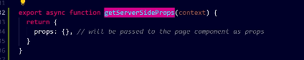

Now inside props we pass the object having key value pairs Now we go inside a component and add props to it as shown below

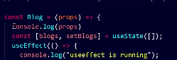

Now both should be in the same file Now you will see what are we passing in the props inside the function we are exporting will be passed to the component as props in the same file. And these was function used to run on server side Now we cut and paste the useEffect code in the getServersideProps and remove the useEffect that means we did not populate through js in client side, we are populating through client side so we will jusr make the api request there in getServerSideProps

Out getServerSideProps would look like below now

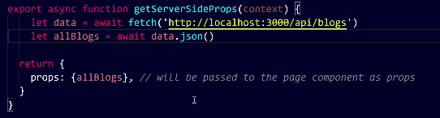

And the component will be like below

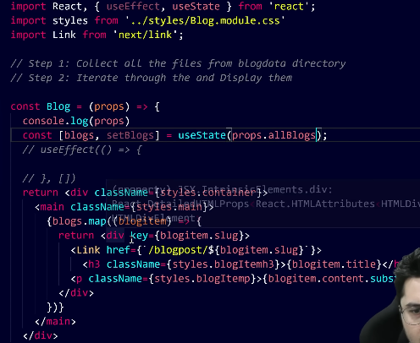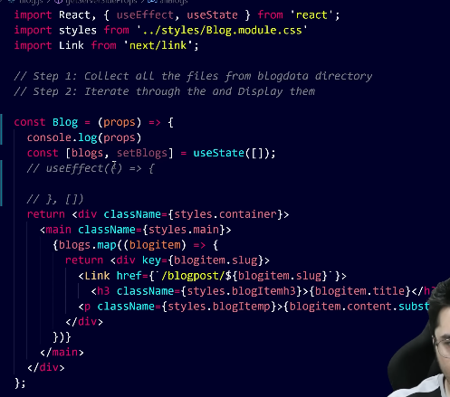

But now in newer version we have server side component and they does not use useState hook Now our new version look like below

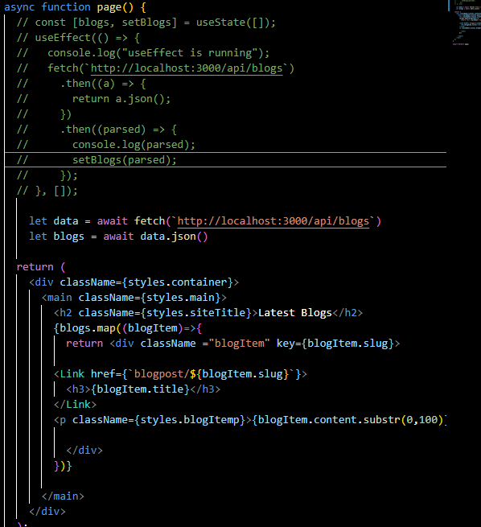

Now if you see your source code now there will be content as shown below

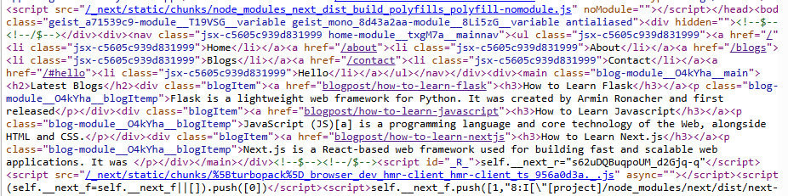

I hope you understood server side rendering . Tou would ask why we did this the page looked fine before we do this to populate request on time and generate HTML on request time. When we do it the data will be in HTML page source too. In Next lesson we will learn about static site generation.

Now teacher did the same way to blog but with older way Now we could not use useRouter in the getServerSideProps so we used to get the params in context parameter we use in getServerSideProps it will contain your parameter sent by url

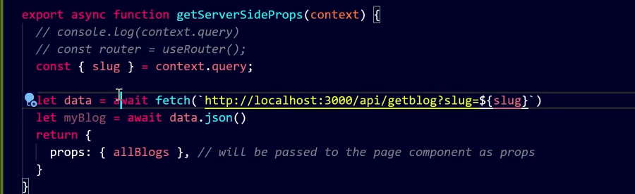

Now our getServerProps did look like above

And our component did look like below

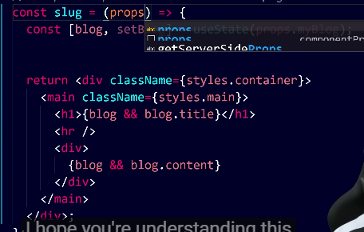

But in our newer version our server component code look like below

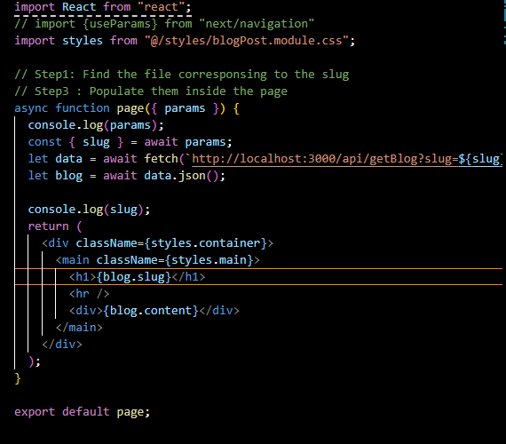

The params here are promise and they get resolved asynchronously so we need to await them as shown above

Now if you see page source then you can see the content. Sow that’s how our server side prop function works and this process is called server side rendering. we did server side rendering. Now we understand server side rendering

We know pre rendering has two strategies one is server site generation and another is server side render and static site generation Through both these strategies we can pre render which means our HTML or data of our blogpost that will go to the client rendered beforehand the client won’t have to fetch through API. We did this using server side rendering. We did this by getServerSideProps function

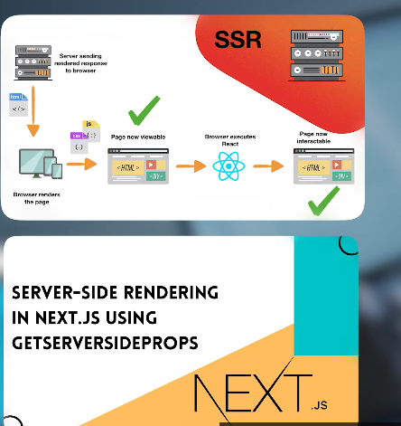

Today we will learn how to use getStaticProps and what getStatic path is . why we did require these two functions when create static site and when we were doing server side rendering then there was only one function we will see why there are two functions in static way what getStaticPaths and getStaticProps do? We will understand it very well.

We learned server side rendering and learned its meaning the server tells the client there is no need to request API means it tells the browser don’t execute js to fetch from API I will do all this work for you so this is our server side rendering Now we will learn about static site generation what happens here is that with the help of Next.js we build a static site in Next js you say we don’t want to run APIs or worry about server just build a static site and I will deploy it like I run a locally written HTML page.

We will replace the getserverSiteProp with getstaticprop we want that a static site be generated and for it we have two function in Nextjs we copy the code for getStaticProp in fact Teacher want to run for getStaticPath

Now We will see what it did so we pasted the getStaticPaths in the [slug].js(old way) So what we are doing is generating a static site that is HTML pages like we see in Home page, about page and all our pages we want to generate them ahead of time by default To do so we need to know which data comes from where so from where will the blog.js data come from

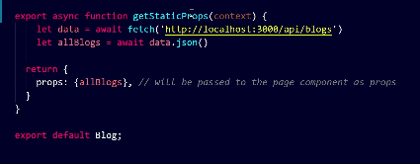

Now getStaticProp Now this function run on server side(who knows) so my API won’t run when I build my site (maybe it is done when our server is not running(who knows)) so we have to replace it logically So getStaticProp will do it will give prop to the blog.js and the html will be hydrated in blog.js and your static site will be generated in folder names as out and now we will do the same in [slug].js(older way) Now we will see what getStaticProp and getStaticPath used to do we are using getStaticProps to run props on server and bring them For example we have a page ler take how to learn flask and we want to generate its content so what it will do? We will bring data from blogData and give it to html. But how many blogs we many blogs can I generate this way because [slug].js(older version) is written here How many pages we have to generate of slug Fo now it is three but how do I tell that to Next.js we will tell that by getStaticPath so what we will do here

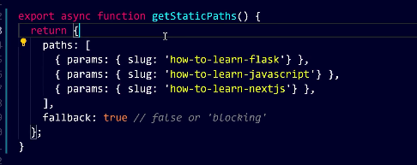

We will do something like to tell how many pages we want to generate for now we have hard coded it for three blogs but in future we make it dynamic .the params in getStaticProps we get through content.params(who knows maybe from getStaticPaths)

So now in getStaticProps and inside it we were running the API as shown below but when we build the app my API won’t be available we wil direct;y copy the logic here

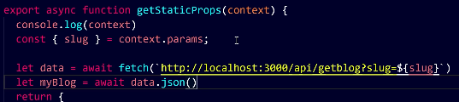



In package.json we did something like above and they do these steps

• Build the app (next build)

• Convert it into static files (next export)

• Output everything into the out/ folder

The script in package.json helps us tun script with the help of yarns

but now export is done by configuration in next.config.ts. and we run the command npm run build now and for export out next.config look like below

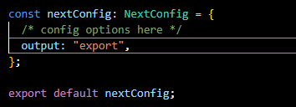

For now we see older version now we run yarn export then it will try to build out site as a static site but I can see some errors

There is something image related error we see often (who knows)

And he saw the same error which I saw that is of not getting the data from api (as the server was running the api and it is vlosed to sun the build command )

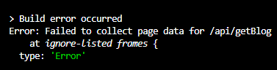

Now you might say that you run the api by yarn dev in another terminal it is not a good approach so to use API So we need ot apply logic rather than using API of server.

We could not use Image component while building SSG but I am not getting error here now after running the build command

We will get the out folder youc an run live server and it will workd but in my case it is not working it will look complex but it is good for SEO.

It speciality is that it is a static site not an next js site

Now problem with this is that it will give separate files and will not create folder like structure each ahvning theit own index.html as hsow belw

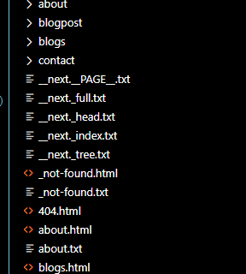

But if we want such structure such that if we reload the page then it should not show 404 error or show folder structure we use

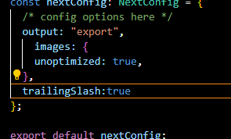

Trailing slash property in nextconfig.ts

Now our folder structure look like below

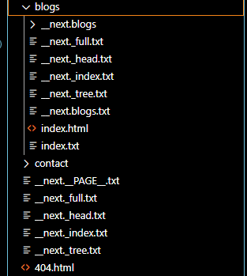

Now it will not solve the problem if re reload the page

So now we see the summary previously we were using getServerSideProps(now server component) generating html before sending to the client So client requested the server which is the nextjs server the server on behalf of client executed the whole js through props and hydrated the page and sent it to the client so it will be easy for the client and that can be displayed and clent don’t have to work hard and run js. If client foe not face issues with slow internet either because we are directly sending HTML Client does not have to send different API request as a result by getServerSideProps(now server component ) server will take thae whole responsiibilty and the site will be fast to some extent and with that is we update out site then we will get live update(who knows) but there is getStatic in this lesson teaher talked about second strategy what it says is that client sent server request the server has all the whole static site (in modern case cache data is using nextjs export)already ready . It says it won’t put effort and it has it ready Its onlyy work is to give you requested page so the out directory will be made by the sertver(in modern case ot make a fully static site maybe in older case used to use with Nextjs (who knows)) the server oly has to now throw the pages(in modern case ).someone just ask for a page then server will just give it the client and server don’t have to put in the effort and the whole page is found ,its very fast If we use CDN which is optimised for content delivery the difference between CDN and server is that the server is not as optimised CDN for content delivery (who knows) CSN’s purpose it to give files to the client at vary fast pace and even the client praises it. Another feature of CSN is that files are cached at different location This means if you access from Kolkata you will get quickly through Kolkata CDN So this was out getStaticProps (in older case but in modern it is by nextjs who is SSG or SSR by analyzing the code) and now teacher says to impoement static site we may need two function to build a static site since there was [slug].js (in olderversion) and they are coming dynamically blog.js was simple where we only want blogs which we get props from getStaticProp(server component) where we told it to fetch all the blogs and whenever we generate in the out folder and the component will be populated. But In [slug].js we need two things. First we need content but along with content I want how many slug can be, and to convey it we use getStaticPath ( in modern version we use get generateStaticParams ) that how many varieties of this page exists. How many pages is generated. Teacher di it manually but we can do it pragmatically by reading the files in blogData directory. It woulf have been optimal then only I have to add to blogData and we would be done.

In getStaticProps what used to do is that if we get a slug then how we can get slug data, getStaticProp will give that data in the form of prop. And then we did run next export to produce the work in out folder (in modern we run npm run build with some configuration in config file) that is a static site bindle. Our out folder will be generated. And then we can host out folder anywhere as a static file. Its drawback is that if we update our blogs thee updates won’t go to the out folder till I don’t run Next export(or nm run build in modern Next.js). If we make another end point in the blogData folder then you won’t see the update. That’s why people use getServerSideprops whenever they want to display changing data their changes are fast. Either you have to build it again very fast or you can use getServerSide props(simple server component with no cache in fetch) so you will generate a server side and perform server side rendering.